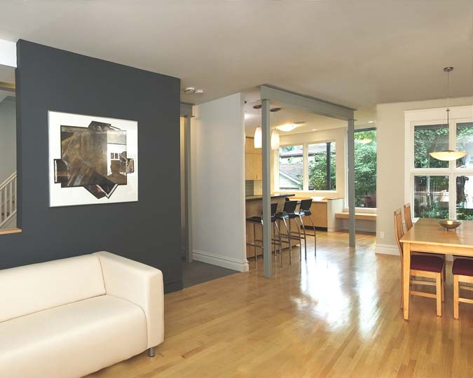

**Before we can start marketing any home that requires photography, several matters must be addressed.**

**This ensures the home will be presented at its best to prospective tenants.**

Elders Real Estate

60 Reibey Street, Ulverstone

Phone: 6425 2722

**KEY AREAS WHICH REQUIRE ATTENTION:**

**LAWNS: To be mowed and edged**

**GARDEN BEDS: To be free of weeds**

**RUBBISH: Yard and Interior to be removed**

**MOULD: Bathrooms, Kitchens, Anywhere – to be removed.**

**WALLS: To be washed (if there are lots of marks we strongly suggest they be painted)**

**COBWEBS: To be removed**

**We also attach a checklist, which is also supplied to our Tenants, explaining the standard we require the home to be maintained in.**

**This may help assure the home is presented at its best when we complete the ongoing inspection report prior to the tenancy commencing.**

PRESENTATION IS CRUCIAL TO FINDING A QUALITY TENANT